Enhance Cloud Security with AWS IAM
Hamsa Isa | Project Documentation
As acting security engineer for “NextWork,” I set up an AWS environment where a new, restricted user (representing a summer intern) could work freely in development — but was completely blocked from touching production. I built and tested this using AWS IAM.

Step 1: Tag the EC2 Instances
I launched two EC2 instances and tagged each one by environment: production-hamsa (Env: production) and development-hamsa (Env: development).
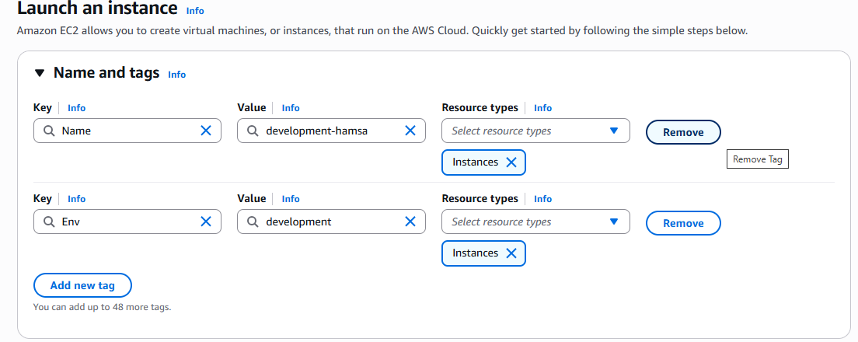
Tagging the development instance with Name and Env
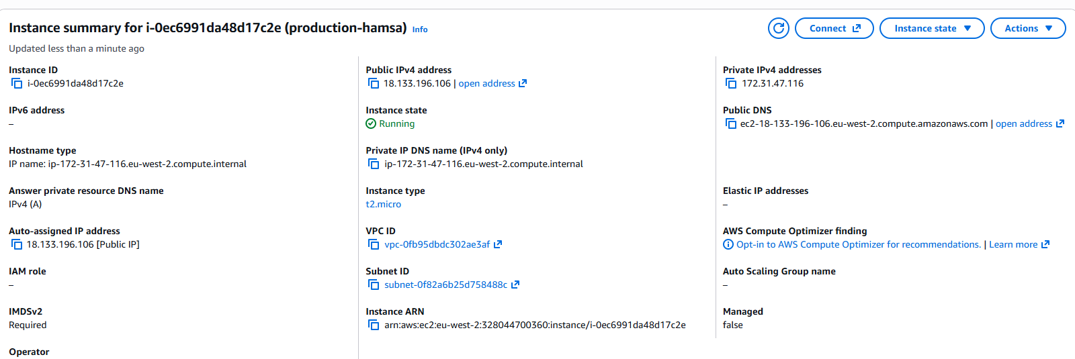
production-hamsa running, tagged Env: production
Why: Tags let the IAM policy target resources by label instead of by ID — so the rule works on any instance carrying that tag, now or in future.

Step 2: Write the IAM Policy
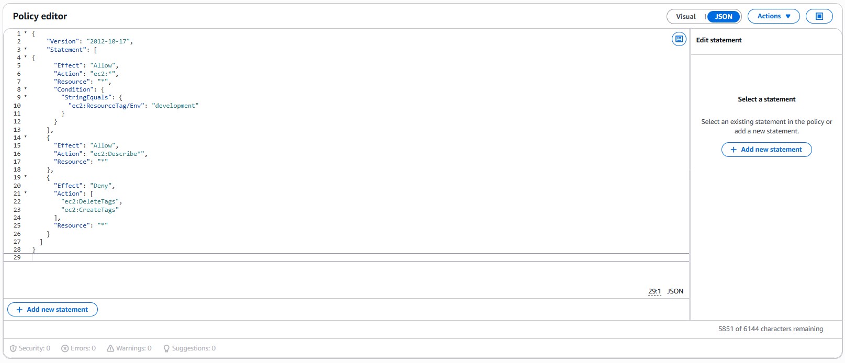
Custom JSON policy in the IAM policy editor
Allow ec2:* only if Env = "development"
Allow ec2:Describe* on everything (read-only view)
Deny CreateTags / DeleteTags on everything
Why: The first rule grants full control over development only. The second lets the user still see production without touching it. The third stops anyone bypassing the whole thing by simply re-tagging production as “development.”

Step 3: Create an Account Alias
I created a custom sign-in URL for the account: https://hamsa-isa.signin.aws.amazon.com/console
Why: Purely a usability step — it makes the login link easy to share with a new user. It has no effect on permissions or security.

Step 4: Create the User Group and User
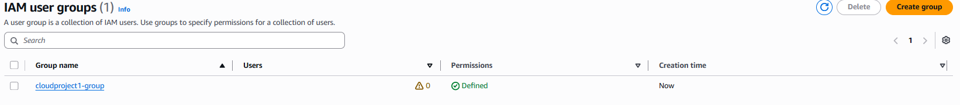
User group “cloudproject1-group” with the policy attached
I created a group, attached the policy to it, then created a user — devhamsa2 — and added them to the group.
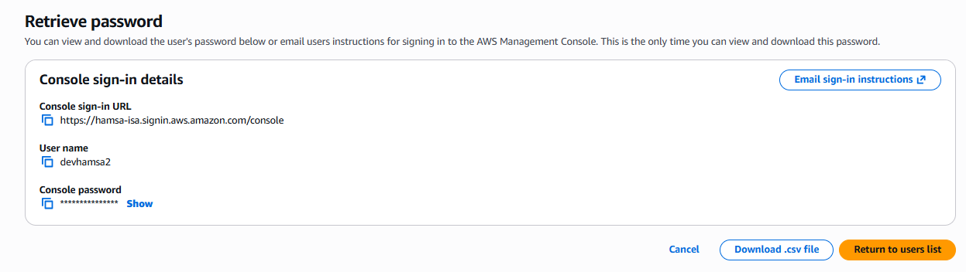
Sign-in details generated for devhamsa2
Why: Assigning permissions at group level means any future user added to this group inherits the same access automatically — no need to configure each user individually.

Step 5: Test the Restricted User
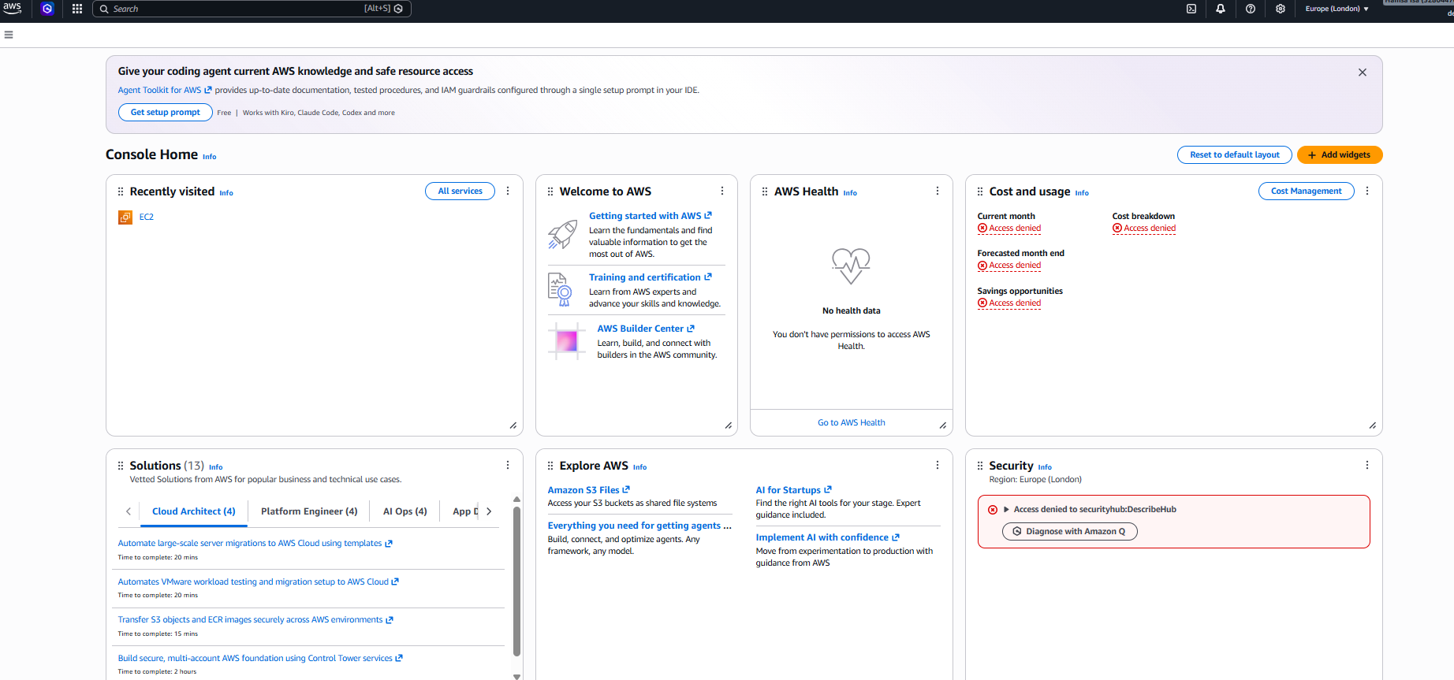
Logged in as devhamsa2 — billing, cost, and security panels all show Access Denied
Denied: not authorized to stop production-hamsa
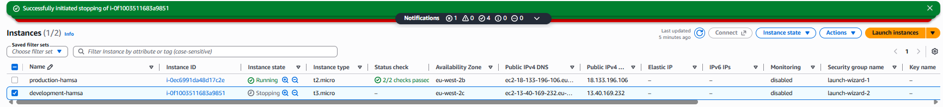
Success: development-hamsa stopping, production-hamsa still running
Why: I didn't assume the policy worked — I logged in as the actual restricted user and proved both outcomes myself: blocked on production, allowed on development.

Result
devhamsa2 could stop the development instance, but was denied on production — entirely by design, enforced through the tag-based IAM policy, group, and account alias set up above.

